/* Ashok IPBC Morgage_Project R1SP3 Story4 Lab.docx 7.26.18*/

Homework:

4. Complete R1:SP3: Story 4 – Do Error handling on the data. For any problems, notify the loan officer via email so they can fix the errors. Explain the entire process with explanations, screenshots.

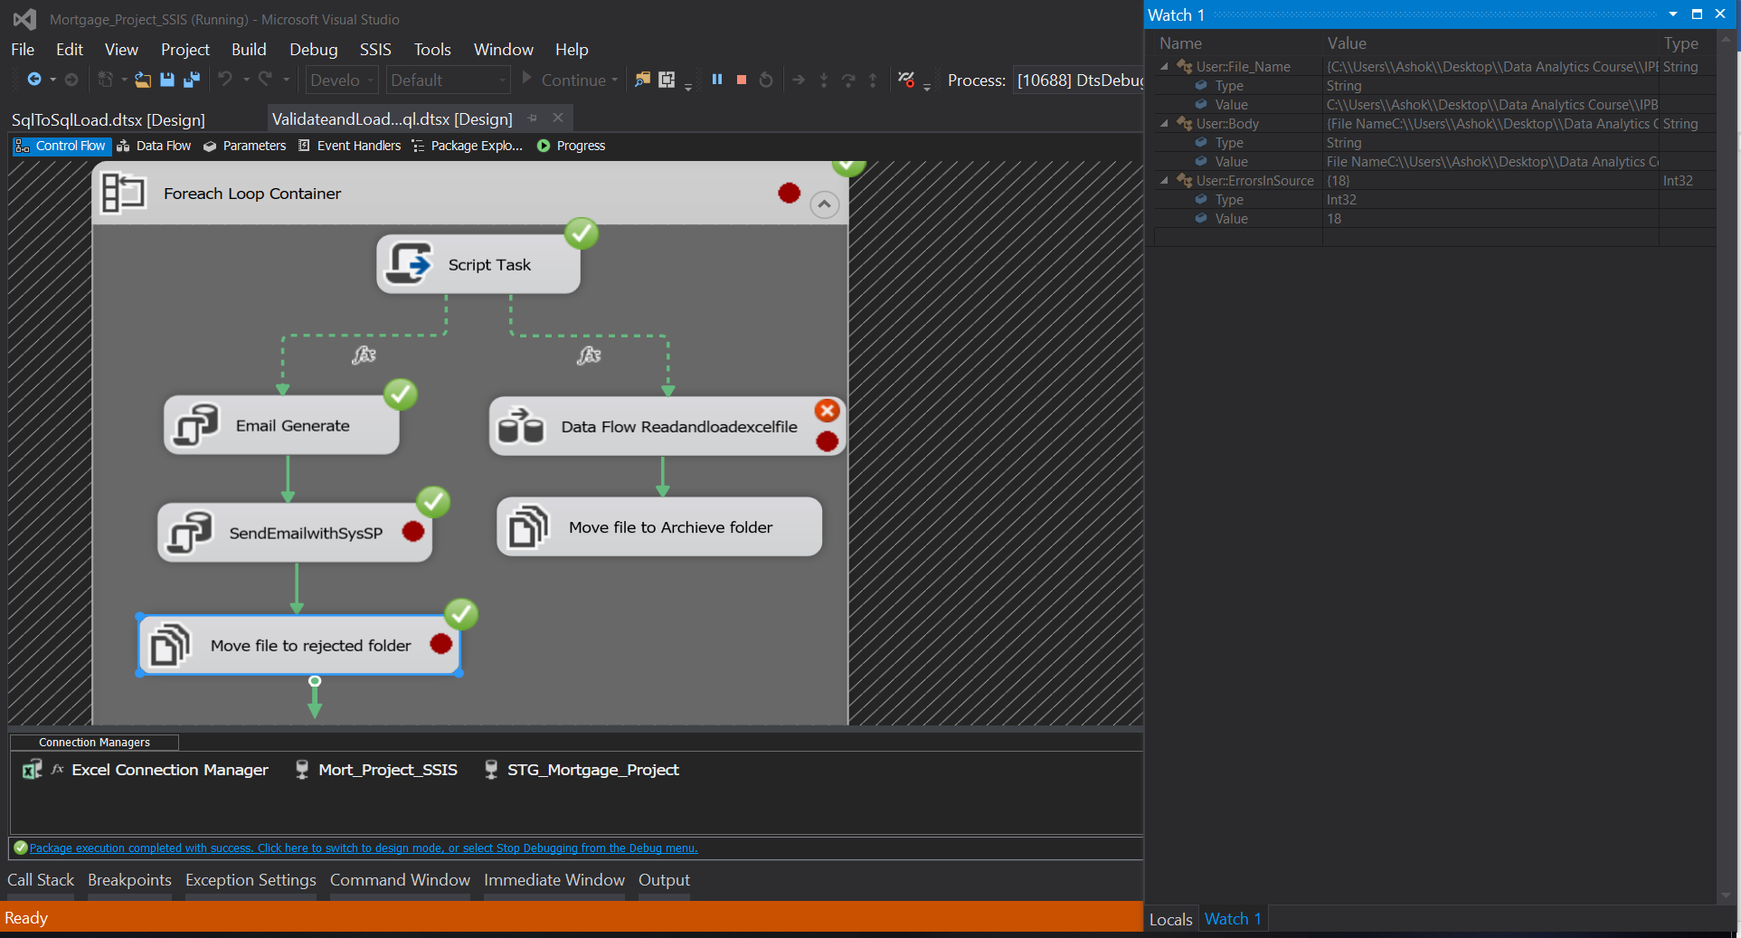

Video(s) to Submit:

1. Copy and paste the link to your video(s) as part of your homework.

* SQL BI Interview Questions: SSIS – What is MULTICAST, MERGE JOIN and CONDITIONAL SPLIT
* SQL BI Interview Questions: SSIS – What is the difference between UNION ALL and MERGE Transformations

What to Submit:

2. Watch, Comment &amp; take screenshots of your comments from 3 other videos on the same

topic (per question). Comments must be 20+ characters. Leave comments based on

presentation, delivery and/or technical details. Your critiques will help you be more

conscious of your own videos. (3 comment screenshots per Video Question)